DLL HELL is a problem where one application will install a new version of the shared component that is not backward compatible with the version already on the machine. Causing all the other existing applications that rely on the shared component to break. With .Net strong named assembly we don’t have DLL hell problem any more.

Dll hell problem can occurs as shown in picture below.

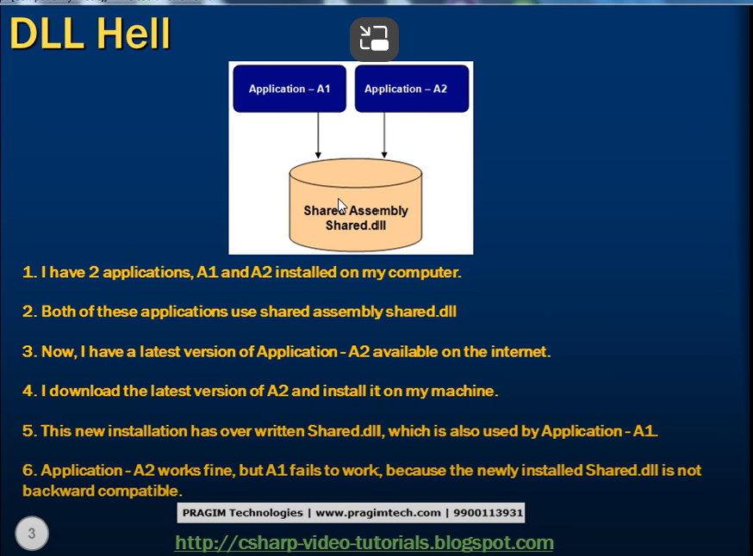

To solve it.

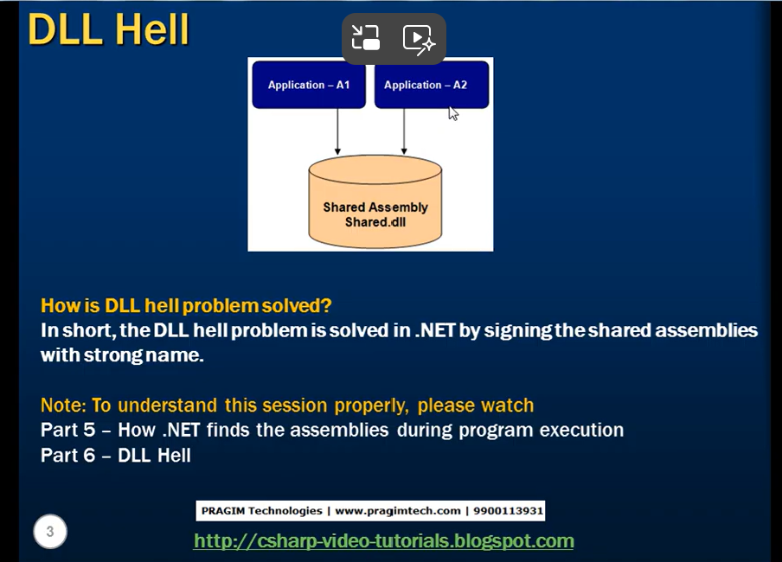

We can solve this by strongly naming the assemblies.

Clean solution deletes all the assemblies in that solution from your debug folder.